A10 - Reliability and Safety Analysis

Year: 2025 Semester: Spring Team: 10 Project: Smart Card Shuffler

Creation Date: 4/3/2025 Last Modified: October 20, 2023

Author: Brendan McLaughlin Email: btmclaug@purdue.edu

Assignment Evaluation: See the Rubric in the Brightspace Assignment

Reliability Analysis
The components selected for failure analysis are as follows: the STM32 F446RET microcontroller, the Raspberry Pi Zero 2W single board computer, the TMC2209 stepper motor driver, and the L293D dual h-bridge motor driver. The F446RET and the Raspberry Pi were selected because they have both a high level of complexity due to a large number of I/O pins and because they can potentially reach elevated temperatures if their logic modules are in operation for extended periods of time. The TMC2209 stepper motor driver is a likely failure point because it controls the application of 12V at up to 2A per stepper motor phase, meaning there could be upwards of 24W of power flowing through it if just one of the phases is in use. Finally, the L293D dual h-bridge motor driver has been selected for failure analysis because it will be used to control two separate motors driven at 5V and up to 1.2A if both are at maximum power, resulting in 6W of power flowing through it at once. Both motor drivers will be subject to elevated temperatures when in normal use.
There are two main equations to describe the failure rates of these components. The STM32 F446RET and the Raspberry Pi Zero 2W are both 32-bit CMOS-based microcontrollers, so they use the equation:
$λ_{p}=(C_{1}×π_{T}+C_{2}×π_{E})×π_{Q}×π_{L}$ Reference: MIL-HDBK-217F, p. 5-1
The TMC2209 and the L293D are both consider power switching devices, where the failure rate is given by the equation:
$λ_{p}=λ_{b}×π_{T}×π_{A}×π_{Q}×π_{E}$ Reference: MIL-HDBK-217F, p. 6-8
This is the best approximate model for these drivers, since there is no entry in the table for motor drivers or h-bridges, however the assumption of this model may be incorrect.

STM32 F446RET:
Parameter name | Description | Value | Comments regarding choice of parameter value
C_1 | Die complexity | 0.56 | 32-bit CMOS
π_T | Temperature factor | 5.0 | T_J = 85°C MIL-HDBK-217F Table 5.1
C_2 | Package failure rate | 0.08724 | 3 x 10^-5 x 64^1.82, 64-pin LQFP64
π_E | Environmental factor | 0.5 | Ground Fixed
π_Q | Quality factor | 2.0 | Class B-1
π_L | Learning factor | 1.0 | ≥ 2 years
λ_p | Failure rate (per 10⁶ hours) | 5.68724 | Calculated: (0.5 x 5.0 + 0.08724 x 0.5) x 2.0 x 1.0
MTTF | Mean Time To Failure (hours) | 175,900 | 1 / (5.68724 x 10^-6)

Raspberry Pi Zero 2W:
Parameter name | Description | Value | Comments regarding choice of parameter value
C_1 | Die complexity | 0.56 | 32-bit CMOS
π_T | Temperature factor | 5.0 | T_J = 85°C
C_2 | Package failure rate | 0.126 | 3 × 10^-5 × 80^1.82, estimated 80 pins
π_E | Environmental factor | 0.5 | Ground Fixed
π_Q | Quality factor | 2.0 | Class B-1
π_L | Learning factor | 1.0 | ≥ 2 years
λ_p | Failure rate (per 10⁶ hours) | 5.726 | Calculated: (0.56 × 5.0 + 0.126 × 0.5) × 2.0 × 1.0
MTTF | Mean Time To Failure (hours) | 174600 | 1 / (5.726 × 10^-6)

L293D Dual H-bridge Motor Driver:
Parameter name | Description | Value | Comments regarding choice of parameter value
λ_b | Base failure rate | 0.12 | Typical for H-bridge ICs, Table 6.4
π_T | Temperature factor | 5.0 | T_J = 85°C
π_V | Voltage stress factor | 2.0 | 80% of 36V
π_E | Environmental factor | 0.5 | Ground Fixed
π_Q | Quality factor | 2.0 | Class B-1
π_A | Application factor | 10.0 | High power dissipation (600 mA)
λ | Failure rate (per 10⁶ hours) | 12.0 | Calculated: 0.12 × 5.0 × 2.0 × 0.5 × 2.0 × 10.0
MTTF | Mean Time To Failure (hours) | 83333 | 1 / (12.0 × 10^-6)

TMC2209 Stepper Motor Driver:
Parameter name | Description | Value | Comments regarding choice of parameter value
λ_b | Base failure rate | 0.15 | Estimated for stepper control complexity
π_T | Temperature factor | 5.0 | T_J = 85°C
π_V | Voltage stress factor | 2.0 | 80% of 24V
π_E | Environmental factor | 0.5 | Ground Fixed
π_Q | Quality factor | 2.0 | Class B-1
π_A | Application factor | 15.0 | Higher power dissipation (2 A)
λ | Failure rate (per 10⁶ hours) | 22.5 | Calculated: 0.15 × 5.0 × 2.0 × 0.5 × 2.0 × 15.0
MTTF | Mean Time To Failure (hours) | 44444 | 1 / (22.5 × 10^-6)

Based on the calculated failure rates and mean times to failure, it is clear that we must be most worried about failure in the motor drivers. The STM32 and the Raspberry Pi had comparatively low failure rates at <6, whereas the L293D has a failure rate of 12 and the TMC2209 had a failure rate of 22.5. This is not unexpected, as they both draw significantly more power and are used to power actual physical devices. It is difficult to reduce the failure rate of the motor drivers due to a large portion of the failure rate attributing to the application factor, which is based on the current draw and cannot be altered. However, it is possible that the other most significant failure factor, the temperature, could be reduced if more active cooling measures were introduced. In terms of analysis, a more accurate model for the motor drivers would certainly improve the accuracy of the calculation, instead of just applying a blanket power switching device formula to both of them.

Failure Mode, Effects, and Criticality Analysis (FMECA)
For the design of our Smart Card Shuffler, we can define two criticality levels based on the potential impact of failures on user safety and system functionality:
- Critical Failures (Level 1):
  - Definition: Failures that could potentially cause injury to the user or significant damage to the system, such as electrical shocks, overheating leading to fire hazards, or uncontrolled motor operation that could harm the user.
  - Examples: A short circuit in the power supply causing a fire, or a motor driver failure leading to uncontrolled high-speed motor operation.
  - Acceptable Failure Rate (λ): λ < 10⁻⁹ failures per hour (per unit). This stringent requirement aligns with industry standards for failures that could injure the user, ensuring a very low probability of occurrence (e.g., less than 1 failure in 1 billion hours of operation).
- Non-Critical Failures (Level 2):
  - Definition: Failures that do not pose a safety risk but may impair the functionality of the system, leading to degraded performance or system downtime. These failures might inconvenience the user but do not cause harm.
  - Examples: The STM32 F446RET resets due to a power glitch, causing the system operation to fail but no actual user hazard occurring.
  - Acceptable Failure Rate (λ): λ < 10⁻⁶ failures per hour (per unit). This is a more relaxed threshold, appropriate for non-safety-critical failures, allowing up to 1 failure per million hours of operation, which is acceptable for most consumer electronics where user safety is not compromised.
Several assumptions were made during the FMECA analysis that apply across multiple failure modes:
- Operating Environment: The system is assumed to operate in a Ground Fixed (GF) environment, as defined by MIL-HDBK-217F, with moderate temperature and humidity conditions (e.g., 25°C ambient, up to 85°C junction temperature under load). This assumption affects the environmental factor (π_{E}​) and temperature factor (π_{T}​) used in failure rate calculations.
- Component Quality: All components are assumed to be commercial-grade (Class B-1, π_{Q} = 2.0), reflecting typical manufacturing standards for consumer electronics. This assumption influences the overall failure rates and criticality assessment.
- User Interaction: The system is assumed to be used in a controlled manner, with no exposure to extreme conditions (e.g., water ingress, physical shock) unless specified by the schematic. This assumption limits the scope of failure modes to those arising from normal operation.
- Detection Mechanisms: Unless specified in the schematic, failure detection is assumed to rely on observable changes in system behavior (e.g., system shutdown, motor failure). No dedicated diagnostic circuitry is assumed to exist unless noted.

3.0 Sources Cited:

[1] U.S. Department of Defense, MIL-HDBK-217F: Reliability Prediction of Electronic Equipment, Notice 2. Washington, DC: U.S. Department of Defense, 1995. [Online]. Available: https://www.sre.org/pubs/Mil-Hdbk-217F.pdf. [Accessed: Apr. 3, 2025].

[2] STMicroelectronics, STM32F446xC/E: ARM Cortex-M4 32-bit MCU+FPU, 180 MHz, 512 KB Flash, 128 KB SRAM, High-Resolution Timer, CAN, I2S, USB, LQFP64 Package. Geneva, Switzerland: STMicroelectronics, 2023. [Online]. Available: https://www.st.com/resource/en/datasheet/stm32f446re.pdf. [Accessed: Apr. 3, 2025].

[3] Raspberry Pi Ltd., Raspberry Pi Zero 2 W: Quad-Core 64-bit ARM Cortex-A53, 512 MB LPDDR2 SDRAM, 2.4 GHz 802.11 b/g/n Wi-Fi, Bluetooth 5.0. Cambridge, UK: Raspberry Pi Ltd., 2021. [Online]. Available: https://datasheets.raspberrypi.com/rpizero2/raspberry-pi-zero-2-w-product-brief.pdf. [Accessed: Apr. 3, 2025].

[4] Trinamic Motion Control GmbH, TMC2209-LA: SilentStepStick Stepper Motor Driver, 2 A RMS, 5-36 V, UART Interface. Hamburg, Germany: Trinamic Motion Control GmbH, 2020. [Online]. Available: https://www.analog.com/media/en/technical-documentation/data-sheets/TMC2209-LA_Datasheet_Rev1.09.pdf. [Accessed: Apr. 3, 2025].

[5] STMicroelectronics, L293D: Push-Pull Four Channel Driver with Diodes, 600 mA Output Current, 4.5 V to 36 V Supply Voltage. Geneva, Switzerland: STMicroelectronics, 2008. [Online]. Available: https://www.st.com/resource/en/datasheet/l293d.pdf. [Accessed: Apr. 3, 2025].

Appendix A: Schematic Functional Blocks

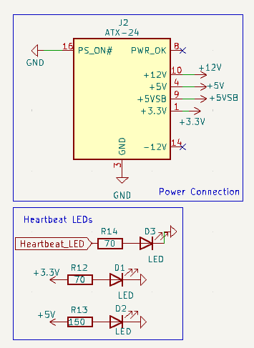
Figure 1: Power System Functional Block

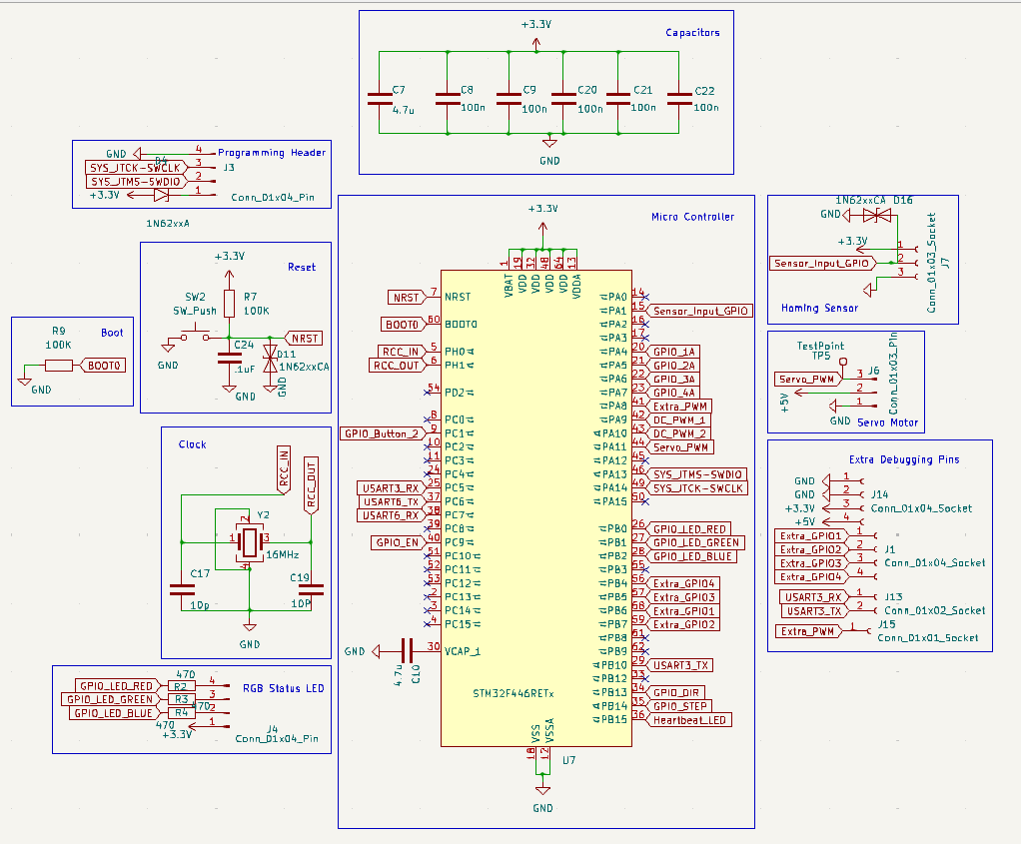
Figure 2: STM32 F446RET Functional Block

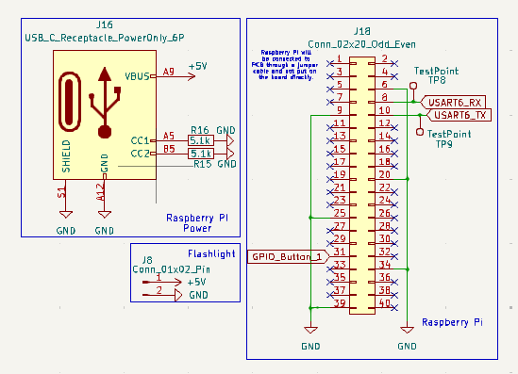
Figure 3: Raspberry Pi Zero 2W Functional Block

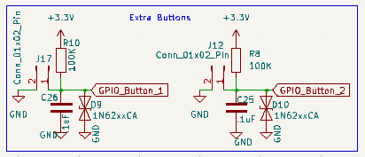
Figure 4: Extra Buttons Functional Block

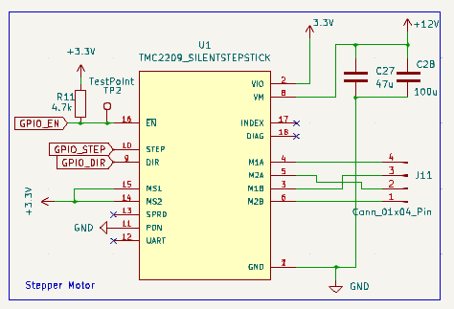
Figure 5: Stepper Motor Driver Functional Block

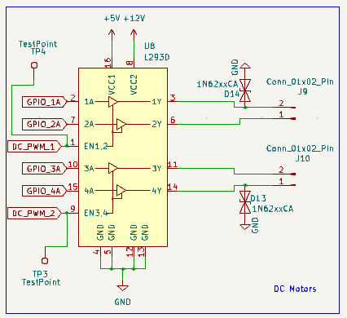
Figure 6: DC Motor Driver Functional Block

Appendix B: FMECA Worksheet

Subsystem: Power System (Figure 1)
Failure No. | Failure Mode | Possible Causes | Failure Effects | Method of Detection | Criticality | Remarks
1 | Loss of +12V Output | Open circuit in +12V line (J2 pin 10), short to GND, ATX power supply failure | Disables +12V-dependent components (e.g. motors). System may halt. | 12V components fail to operate. No direct indicator. | Level 2 | Stepper Motor will not function.
2 | Loss of +5V Output | Open circuit in +5V line (J2 pin 4), short to GND, ATX power supply failure | Disables +5V components (e.g. Raspberry Pi). LED2 off. System may halt. | LED2 does not light up. +5V components fail. | Level 2 | Pi and DC motors will not function.
3 | Loss of +3.3V Output | Open circuit in +3.3V line (J2 pin 1), short to GND, ATX power supply failure | Disables +3.3V components (e.g. STM32). LED1 off. System may halt. | LED1 does not light up. +3.3V components fail. | Level 2 | STM32 will not function.
4 | Short Circuit on +5V Rail | Short to GND on +5V line (J2 pin 4), downstream component failure | ATX supply may shut down. Overheating risk. LED2 off. System powers off. | System powers off. LED2 off. Possible burning smell. | Level 1 | Major fire hazard
5 | Short Circuit on +3.3V Rail | Short to GND on +3.3V line (J2 pin 1), downstream component failure | ATX supply may shut down. Overheating risk. LED1 off. System powers off. | System powers off. LED1 off. Possible burning smell. | Level 1 | Major fire hazard
6 | Open circuit in LED1 path (LED1, R14, D3 failure) | Open circuit in LED1 path (LED1 R14 D3 failure) | LED1 does not light up. No impact on other components; monitoring affected. | LED1 does not light up. System may still operate. | Level 2 | Use multimeter to confirm +3.3V presence if LED1 fails.
7 | Open circuit in LED2 path (LED2, R12, R13, D1/D2 failure) | Open circuit in LED2 path (LED2 R12 R13 D1/D2 failure) | LED2 does not light up. No impact on other components; monitoring affected. | LED2 does not light up. System may still operate. | Level 2 | Use multimeter to confirm +5V presence if LED2 fails.

Subsystem: STM32 F446RET and Necessary Support Systems (Figure 2)
Failure No. | Failure Mode | Possible Causes | Failure Effects | Method of Detection | Criticality | Remarks
1 | Loss of +3.3V Power to STM32 | Open circuit in +3.3V rail, decoupling capacitor failure (C7 C9 C20 C21 C22), upstream power supply failure | STM32 fails to operate. System halts. Heartbeat LED (U7) and RGB LED (U3) off. | System does not function. Heartbeat LED (U7) off. RGB LED (U3) off. | Level 2 | Assumes upstream power failure (analyzed in previous block). No safety hazard, but full system failure.
2 | Short Circuit on +3.3V Rail | Short to GND on +3.3V rail, capacitor failure (C7 C9 C20 C21 C22), STM32 internal failure | Upstream supply may shut down. Overheating risk. STM32 damage. System powers off. | System powers off. Possible burning smell. Heartbeat LED (U7) off. | Level 1 | Major fire hazard, assume upstream power failure.
3 | Clock Failure (16 MHz Crystal Stops) | Crystal (Y2) failure, open circuit, capacitor failure (C17 C19) | STM32 fails to operate. System halts. RGB LED (U3) may freeze or turn off. | System does not function. RGB LED (U3) may freeze/off. Heartbeat LED (U7) may be on. | Level 2 | Outcome depends on software, may fall back on internal clock.
4 | Reset Circuit Failure (Stuck in Reset) | Push-button (SW2) stuck closed, short to GND on NRST, capacitor (C11) failure | STM32 remains in reset. System does not function. RGB LED (U3) off. | System does not function. RGB LED (U3) off. Heartbeat LED (U7) may be on. | Level 2 | Should not be an issue outside of system development
5 | Reset Circuit Failure (No Reset Possible) | Open circuit in reset path (SW2 R7 failure), NRST pin damage | STM32 cannot reset. Unpredictable behavior if locked up. | System behaves erratically. Manual reset fails. | Level 2 | Unable to reset STM, not an issue outside of development setting.
6 | BOOT0 Pin Failure (Stuck High) | Pull-down resistor (R9) failure, short to +3.3V on BOOT0 | STM32 boots into bootloader mode. System does not execute main program. | System does not execute program. RGB LED (U3) may indicate bootloader mode. | Level 2 | STM will constantly attempt boot.
7 | Programming Header Failure (Cannot Program) | Open circuit in SWDIO/SWCLK (J3), short to GND/+3.3V, STM32 SWD failure | Inability to program/debug STM32. System operation unaffected if programmed. | Programming tool fails to connect. System may still operate. | Level 2 | Cannot load software onto STM.
8 | RGB Status LED Failure (U3 Off) | Open circuit in LED path (U3 R2/R3/R4 failure), GPIO pin failure (PB0 PB1 PB7) | RGB LED does not light up. No impact on STM32 operation; monitoring affected. | RGB LED (U3) does not light up. System may operate normally. | Level 2 | Use multimeter to check GPIO pins if LED fails.
9 | Heartbeat LED Failure (U7 Off) | Open circuit in LED path (U7 failure), +3.3V rail failure | Heartbeat LED does not light up. No impact on STM32 operation; monitoring affected. | Heartbeat LED (U7) does not light up. System may operate. | Level 2 | Use multimeter to confirm +3.3V presence if LED fails.

Subsystem: Raspberry Pi Zero 2W Power and Board Connection, with Computer Vision Flashlight (Figure 3)
Failure No. | Failure Mode | Possible Causes | Failure Effects | Method of Detection | Criticality | Remarks
1 | Loss of +5V Power to Raspberry Pi | Open circuit in +5V VBUS (J16 pin A9), USB-C connector failure, upstream power failure | Raspberry Pi fails to operate. System halts. Flashlight (J8) off. | System does not function. Raspberry Pi does not boot. Flashlight off. | Level 2 | Assumes upstream power issue. No safety hazard in this block.
2 | Short Circuit on +5V Rail | Short to GND on +5V VBUS (J16 pin A9), Raspberry Pi failure, short at J8 | Upstream supply may shut down. Overheating risk. Raspberry Pi damage. Flashlight off. | System powers off. Possible burning smell. Flashlight off. | Level 1 | Assumes overcurrent protection; fire risk if absent.
3 | USB-C CC Line Failure (CC1/CC2 Open) | Open circuit in CC1/CC2 (J16 pins A5 B5), resistor failure (R16 R15) | USB-C power delivery fails. Raspberry Pi does not receive +5V. System halts. Flashlight off. | System does not power on. Raspberry Pi does not boot. Flashlight off. | Level 2 | Rasbperry Pi will not function at all.
4 | Flashlight Header Short Circuit | Short to GND at J8, external device failure | Upstream supply may shut down. Overheating risk at J8. Raspberry Pi damage. | System powers off. Possible burning smell at J8. Flashlight off. | Level 1 | Assumes overcurrent protection; external failure can propagate.
5 | GPIO Button Failure (Stuck High/Low) | GPIO_BUTTON_1 (J18 pin 31) failure, short to GND/+3.3V, external button failure | Raspberry Pi misinterprets button state. Incorrect system behavior. | System does not respond to button presses as expected. | Level 2 | Bluetooth reset button failure, connection will have major software issues.
6 | UART Communication Failure (RX/TX) | Open circuit/short on UART6_RX/TX (J18 pins 8 10), Raspberry Pi UART failure | Loss of communication with external devices. System coordination fails. | System does not communicate. Test points (TP8 TP9) show no signal. | Level 2 | No capability for Pi to communicate with STM, system will idle.

Subsystem: Extra Button Connections (Figure 4)
Failure No. | Failure Mode | Possible Causes | Failure Effects | Method of Detection | Criticality | Remarks
1 | Button 1 Failure (Stuck Low) | Push-button (D9) stuck closed, short to GND on GPIO_BUTTON_1, capacitor (C26) failure | GPIO_BUTTON_1 permanently low. System interprets button as always pressed. | System behaves as if Button 1 is always pressed. No response to presses. | Level 2 | Cannot reset Pi Bluetooth module, no real issue.
2 | Button 1 Failure (Stuck High) | Open circuit in button path (D9 failure), pull-up resistor (R10) failure, short to +3.3V | GPIO_BUTTON_1 permanently high. Button 1 functionality lost. | Button 1 presses have no effect. System does not respond. | Level 2 | Bluetooth continuously resetting, system will not be functional but no safety hazard
3 | Button 2 Failure (Stuck Low) | Push-button (D10) stuck closed, short to GND on GPIO_BUTTON_2, capacitor (C25) failure | GPIO_BUTTON_2 permanently low. System interprets button as always pressed. | System behaves as if Button 2 is always pressed. No response to presses. | Level 2 | No Start signal sent to STM, system will continuously Idle
4 | Button 2 Failure (Stuck High) | Open circuit in button path (D10 failure), pull-up resistor (R8) failure, short to +3.3V | GPIO_BUTTON_2 permanently high. Button 2 functionality lost. | Button 2 presses have no effect. System does not respond. | Level 2 | STM will send immediate start, effects depend of future software implementation
5 | Loss of +3.3V to Button Circuit | Open circuit in +3.3V rail, upstream power supply failure | Buttons lose pull-up voltage. GPIO pins may float or stay low. Incorrect behavior. | Buttons do not function as expected. Erratic input detection. | Level 2 | Assumes upstream power failure (analyzed previously). No safety hazard, effects above.

Subsystem: Stepper Motor Driver (Figure 5)
Failure No. | Failure Mode | Possible Causes | Failure Effects | Method of Detection | Criticality | Remarks
1 | Loss of +12V Motor Power (VM) | Open circuit in +12V VM line, capacitor failure (C27 C28), upstream power failure | TMC2209 cannot drive motor. Motor stops. System functionality halts. | Motor does not operate. System functionality fails. | Level 2 | Unable to turn sorting wheel.
2 | Loss of +3.3V Logic Power (VIO) | Open circuit in +3.3V VIO line, upstream power failure | TMC2209 logic fails. Motor stops. INDEX signal (TP2) may not function. | Motor does not operate. INDEX signal (TP2) shows no activity. | Level 2 | No safety hazard, uncertain of failure outcome of this voltage supply.
3 | Short Circuit on +12V VM Rail | Short to GND on +12V VM line, capacitor failure (C27 C28), TMC2209 failure | Upstream supply may shut down. Overheating risk. TMC2209 damage. Motor stops. | System powers off. Possible burning smell. Motor does not operate. | Level 1 | Major fire hazard.
4 | Short Circuit on +3.3V VIO Rail | Short to GND on +3.3V VIO line, TMC2209 failure | Upstream supply may shut down. Overheating risk. TMC2209 damage. Motor stops. | System powers off. Possible burning smell. Motor does not operate. | Level 1 | Major fire hazard.
5 | Enable Pin Failure (EN Stuck High) | Short to +3.3V on GPIO_EN (pin 16), GPIO pin failure | TMC2209 remains disabled. Motor does not operate. System functionality halts. | Motor does not operate despite control signals. INDEX signal (TP2) inactive. | Level 2 | Motor will not function, inability to turn sorting wheel
6 | Enable Pin Failure (EN Stuck Low) | Short to GND on GPIO_EN (pin 16), GPIO pin failure | TMC2209 always enabled. Unintended motor operation if STEP/DIR active. | Motor operates unexpectedly when it should be disabled. | Level 1 | Uncontrolled motor movement could be hazardous if speed is high.
7 | STEP/DIR Signal Failure | Open circuit/short on GPIO_STEP/DIR (pins 10 9), GPIO pin failure | Motor stops or moves erratically. System functionality fails. | Motor does not move as expected. INDEX signal (TP2) may show irregular activity. | Level 2 | Wheel may not rotate to intended position.
8 | Motor Output Failure (Open Circuit) | Open circuit in motor lines (M1A M1B M2A M2B at J11), stepper motor failure | Motor does not operate. System functionality requiring movement halts. | Motor does not move despite control signals. INDEX signal (TP2) may be active. | Level 2 | Wheel will not turn at all.
9 | Motor Output Short Circuit | Short between motor lines (e.g. M1A to M1B), stepper motor failure | TMC2209 may shut down. Overheating risk. TMC2209 damage. | Motor does not operate. Possible burning smell or damage to TMC2209/motor. | Level 1 | TMC2209 has overcurrent protection but fire risk if protection fails.

Subsystem: DC Motor Driver (Figure 6)

Failure No. | Failure Mode | Possible Causes | Failure Effects | Method of Detection | Criticality | Remarks
1 | Loss of +5V Logic Power (VCC1) | Open circuit in +5V VCC1 line (pin 16), upstream power failure | L293D logic fails. Motors stop. | Motors do not operate despite control signals. | Level 2 | Assumes upstream power failure (analyzed previously). No safety hazard.
2 | Short Circuit on +5V VCC1 Rail | Short to GND on +5V VCC1 line (pin 16), L293D failure | Upstream supply may shut down. Overheating risk. L293D damage. Motors stop. | System powers off. Possible burning smell. Motors do not operate. | Level 1 | Major fire hazard.
3 | Enable Pin Failure (EN1/EN2 Stuck High) | Short to +5V on GPIO_PWM_1/2 (pins 2 7), GPIO pin failure | L293D channels 1/2 always enabled. Unintended Motor 1 operation. | Motor 1 (J9) operates unexpectedly when it should be disabled. | Level 2 | Card feeder motor 1 will not work properly, card feeder system will fail.
4 | Enable Pin Failure (EN3/EN4 Stuck High) | Short to +5V on GPIO_PWM_3/4 (pins 10 15), GPIO pin failure | L293D channels 3/4 always enabled. Unintended Motor 2 operation. | Motor 2 (J10) operates unexpectedly when it should be disabled. | Level 2 | Card feeder motor 2 will not work properly, card feeder system will fail.
5 | Enable Pin Failure (EN1/EN2 Stuck Low) | Short to GND on GPIO_PWM_1/2 (pins 2 7), GPIO pin failure | L293D channels 1/2 disabled. Motor 1 does not operate. | Motor 1 does not operate despite control signals. | Level 2 | Card feeder motor 1 not functional, unknown how feeder will react.
6 | Enable Pin Failure (EN3/EN4 Stuck Low) | Short to GND on GPIO_PWM_3/4 (pins 10 15), GPIO pin failure | L293D channels 3/4 disabled. Motor 2 does not operate. | Motor 2 does not operate despite control signals. | Level 2 | Card feeder motor 2 not functional, unknown how feeder will react.
7 | Input Signal Failure (1A/2A or 3A/4A) | Open circuit/short on GPIO_1A/2A/3A/4A (pins 1 3 9 11), GPIO pin failure | Motors stop or move erratically. System functionality fails. | Motors do not move as expected (e.g. wrong direction no movement). | Level 2 | Card feeder motor 1 will not work properly, card feeder system will fail.
8 | Motor Output Failure (Open Circuit) | Open circuit in motor lines (1Y 2Y at J9; 3Y 4Y at J10), DC motor failure | Affected motor does not operate. System functionality requiring that motor halts. | Affected motor does not move despite control signals. | Level 2 | Card feeder motor 2 will not work properly, card feeder system will fail.
9 | Motor Output Short Circuit | Short between motor lines (e.g. 1Y to 2Y at J9), DC motor failure | L293D may overheat. Overheating risk. L293D damage. | Motor does not operate. Possible burning smell or damage to L293D/motor. | Level 1 | L293D lacks overcurrent protection; significant fire risk.

